Drone Detector and Jammer User Manual

Main Script

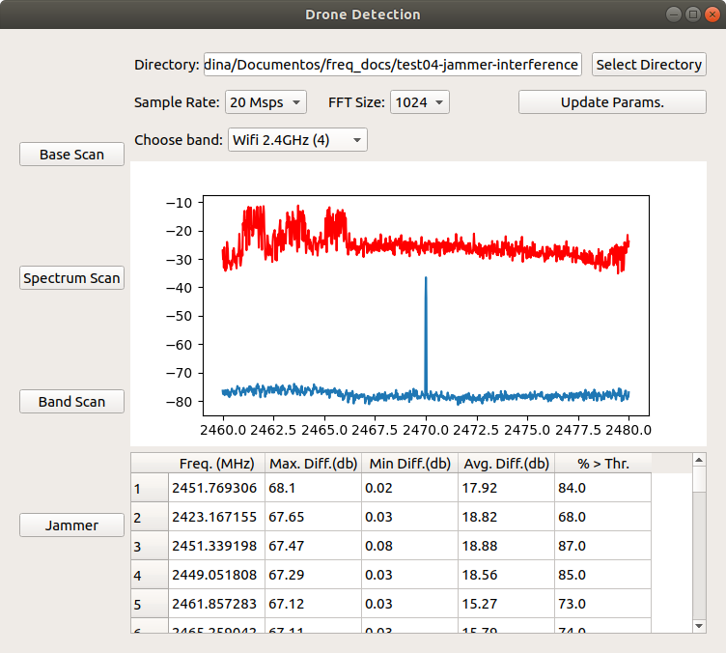

Directory: the folder where the files generated by the scripts are stored. It is recommended that for every new data acquisition, a new folder is created. Pushing the button “Select directory” allows the user to select a folder.

Sample Rate: two options of sample rate in the range of Million sample rate per second (Msps). 10 Msps or 20 Msps. This value indicates the bandwidth: 10 MHz or 20 MHz.

FFT Size: the size of bins in which the signal will be divided after FFT. 1024 or 2048 are the options available.

Choose band: indicates the mode at which the graphic works.
In “CONTINUOUS” mode, it will display one graphic at a time for each of the frequency files stored in the directory, and after 3 seconds will move on to display the next frequency graphic.
In “ALL” mode, it will display all the data found in the directory in one single graphic, usually all the files corresponding to frequencies from 1 MHz to 6 GHz. It also provides additional controls to set the lower and upper frequencies that must be displayed in the graphic.
There are also additional modes, that will display the graphic with preset frequencies, where drone activity is expected such as 433 MHz, 868 MHz and the whole 2.4 GHz.

Graphic: The graphic displays the power values obtained from the base scan script in blue color and the power values from the spectrum and band scan script in red values. All values are in dBm. The graphic will let us verify visually where in the spectrum we can find unusual RF activity.

Table: The table displays all the data obtained from the spectrum scan script with the use of the data obtained from the base scan script. Here we find the frequency and the values that have exceede the threshold, with their respective maximum difference from the base, the minimum difference and the average difference. Also here is displayed the percentage of values that have been above the threshold, out of the total received values.

Base Scan: launches the execution of the base scan script to obtain the base averaged power values for all frequencies between 1 MHz and 6 GHz. The sample rate, FFT size and directory parameters will be passed to the script for the execution. This must be the first script to be executed, since we will always need the base power values for the others scanning scripts to work.

Spectrum Scan: launches the execution of the spectrum scan script to analyze the real time power values and compare them with the base power values. Initially the spectrum scan is for frequencies between 1 MHz and 6 GHz, but the user can change the lower and upper frequency, so the scan can be focused on bands of interest. The sample rate, FFT size and directory parameters will be passed to the script for the execution.

Band Scan: launches the execution of the band scan script to analyze the real time power values and compare them with the base power values. Contrary to the spectrum scan script, we are focused in a given bandwidth and not the whole spectrum available. This script also provides a graphical interface to see in real time the power values. The sample rate, FFT size and directory parameters will be passed to the script for the execution.

Jammer: launches the execution of the jammer script, which is in charge of generating a noise signal within a bandwidth determined by the user. This script is used to interfer or block the communications between a drone and its remote controller.

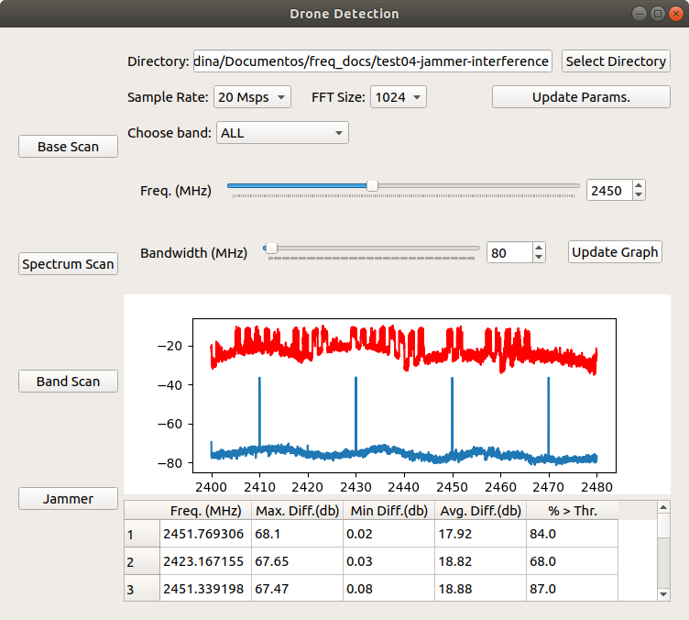

Base Scan

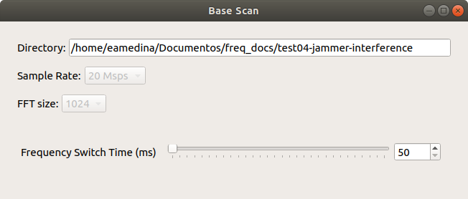
Directory: the folder where the files generated by this script are stored. Files will be generated with the power suffix and will be stored in txt format. This parameter is passed by the main script.

Sample Rate: This value indicates the sample rate and the bandwidth in MHz. This parameter is passed by the main script.

FFT Size: the size of bins in which the signal will be divided after FFT. This parameter is passed by the main script.

Frequency Switch Time (ms): The time the source generates data for a given frequency before moving to the next one. A lower time will produce that a complete spectrum sweep is done faster. A greater time will produce that each frequency has more time to get its data, but will take longer to sweep the whole spectrum.

Spectrum Scan

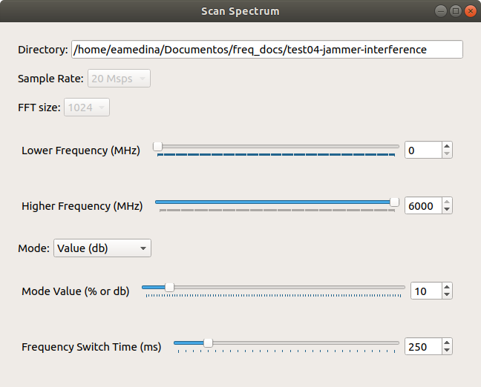

Directory: the folder where the files generated by this script are stored. Files will be generated with the compare suffix and will be stored in txt format. This parameter is passed by the main script.

Sample Rate: this value indicates the sample rate and the bandwidth in MHz. This parameter is passed by the main script.

FFT Size: the size of bins in which the signal will be divided after FFT. This parameter is passed by the main script.

Lower Frequency (MHz): This value indicates the minimum frequency at which the scan will be performed. By default this value is set to 0. This value can be modified by the user to focus on bands of interest and not in the whole spectrum available.

Higher Frequency (MHz): This value indicates the maximum frequency at which the scan will be performed. By default this value is set to 0. This value can be modified by the user to focus on bands of interest and not in the whole spectrum available.

Mode: Indicates the operation mode used to set the threshold value, at which all power values above it will be considered as unusual activity and saved to the file database as an exceeded power value.
The two available modes are Percentage and Fixed. Percentage takes the base value and calculates its treshold based on the percentage value set. If it is set to 10%, all values above 10% of the base value will be considered as unusual.
Fixed mode establishes the threshold as a fixed dB value above the base for each frequency.

Mode value: Indicates the value that will help calculate the threshold. If the mode is percentage it will indicate a percentage value above the base. If the mode is fixed, it will indicate a dB value above the base.

Frequency Switch Time (ms): The time the source generates data for a given frequency before moving to the next one. A lower time will produce that a complete spectrum sweep is done faster. A greater time will produce that each frequency has more time to get its data, but will take longer to sweep the whole spectrum.

Band Scan

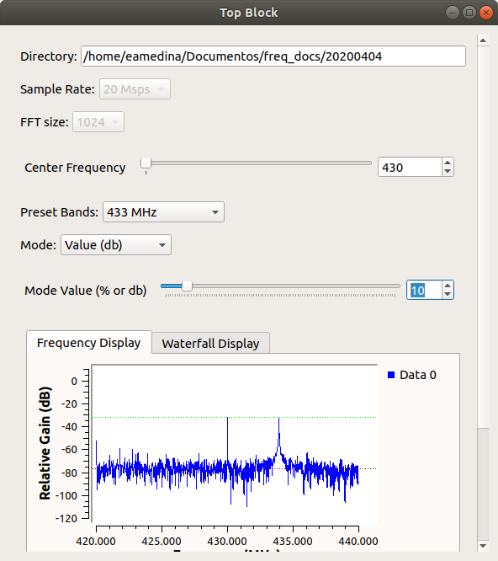
Directory: the folder where the files generated by this script are stored. Files will be generated with the compare suffix and will be stored in txt format. This parameter is passed by the main script.

Sample Rate: this value indicates the sample rate and the bandwidth in MHz. This parameter is passed by the main script.

FFT Size: the size of bins in which the signal will be divided after FFT. This parameter is passed by the main script.

Center Frequency (MHz): the center frequency at which this script operates. This parameter can be changed by the user and in consequence the graphic and the file generated will also reflect the changes.

Preset bands: configuration that will set this script's operating frequency to preset frequencies, where drone activity is expected such as 433 MHz, 868 MHz and the whole 2.4 GHz band.

Mode: Indicates the operation mode used to set the threshold value, at which all power values above it will be considered as unusual activity and saved to the file database as an exceeded power value.
The two available modes are Percentage and Fixed. Percentage takes the base value and calculates its treshold based on the percentage value set. If it is set to 10%, all values above 10% of the base value will be considered as unusual.
Fixed mode establishes the threshold as a fixed dB value above the base for each frequency.

Mode value: Indicates the value that will help calculate the threshold. If the mode is percentage it will indicate a percentage value above the base. If the mode is fixed, it will indicate a dB value above the base.

Graphic: Has a real time representation of the power values received by the SDR. We can see a FFT plot or a waterfall plot. This graphic helps in the detection of signal activity in a given frequency band.

JAMMER

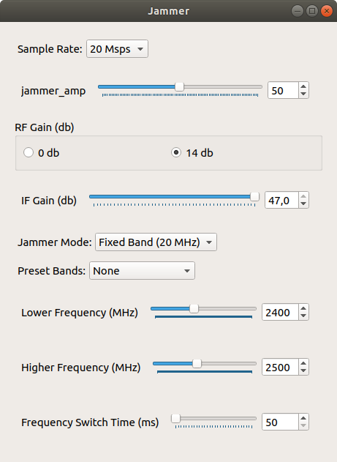

Sample Rate: this value indicates the sample rate and the bandwidth in MHz. This parameter is passed can be selected by the user between 10 Msps and 20 Msps.

Jammer Amplitude: amplitude of the generated noise signal.

RF Gain, IF Gain: software defined gains in dB available by the SDR device.

Jammer Mode: the operating mode of the script. It can be fixed or continuous. In fixed mode we generate a noise signal of the chosen bandwidth that is transmitted in a frequency determined by the value set in Lower Frequency parameter. In continuous mode, the noise signal can be transmitted at different frequencies, hopping between the values set in Lower and Upper frequencies. The hopping time is set by the Frequency Switch Time. The continuous mode helps us transmit the noise signal in a band greater than 20 MHz.

Preset bands: configuration that will set this script's operating frequency to preset frequencies, where drone activity is expected such as 433 MHz, 868 MHz and the whole 2.4 GHz band.

Lower Frequency (MHz): This value in fixed mode indicates the frequency at which the noise will be transmitted. In continuous mode indicates the minimum frequency at which the noise will be transmitted. By default this value is set to 2400 MHz.

Higher Frequency (MHz): This value indicates the maximum frequency at which the noise will be transmitted. This parameter is only taken into account when the script is operating in continuous mode. By default this value is set to 2500 MHz.

Frequency Switch Time (ms): The time the source generates the noise for a given frequency before moving to the next one. This parameter is only taken into account when the script is operating in continuous mode.

